EC-467 Mobile Application Development

BS (CE)-2021 LAB REPORT #7
Submitted By:

Reg. No. | Name
21-CE-009 | Huzaifa Shahbaz

Department of Computer Engineering
HITEC University Taxila
 | Presentation  (Format(0.5)+  Title (0.5)+  Conclusion(1)  +Procedure(2)  +Objective(1)) | Calculation/ Coding | Observation/  Program Results | Total
Total | 5 | 5 | 5 | 15
Obtained

Lab Instructor.
Dr. Muhammad Bilal

LAB REPORT #7
Shared Preferences

Introduction:
Android provides many ways of storing data of an application. One of this way is called Shared Preferences. Shared Preferences allow you to save and retrieve data in the form of key, value pair. The first parameter is the key and the second parameter is the MODE. You can save something in the sharedpreferences by using SharedPreferences. Editor class. We will call the edit method of SharedPreference instance and will receive it in an editor object. Its syntax is Editor editor = sharedpreferences.edit(); editor.putString("key", "value"); editor.commit();
Objectives:
• To get basic understanding regarding Shared Preferences • To get basic understanding regarding how data is saved and retrieved • To get to know about the benefits related to Shared Preferences.

Software used:
Android Studio Iguana
Class Task:
Shared Preferences:
XML CODE OF MAIN ACTIVITY:
<?xml version="1.0" encoding="utf-8"?>
<LinearLayout xmlns:android="http://schemas.android.com/apk/res/android"
xmlns:app="http://schemas.android.com/apk/res-auto"
xmlns:tools="http://schemas.android.com/tools"
android:layout_width="match_parent"
android:layout_height="match_parent"
android:orientation="vertical"
android:padding="20dp"
tools:context=".MainActivity">
<EditText
android:id="@+id/user_name"
android:layout_width="match_parent"
android:layout_height="wrap_content"
android:ems="10"
android:inputType="textPersonName"
android:text="User Name" />
<EditText
android:id="@+id/pass_word"
android:layout_width="match_parent"
android:layout_height="wrap_content"
android:ems="10"
android:inputType="textPersonName"
android:text="PassWord" />
<Button
android:id="@+id/save_btn"
android:layout_width="match_parent"
android:layout_height="wrap_content"
android:onClick="saveButton"
android:text="Save" />
<Button
android:id="@+id/restore_btn"
android:layout_width="match_parent"
android:layout_height="wrap_content"
android:onClick="restoreButton"
android:text="Get" />
<Button
android:id="@+id/delete_btn"
android:layout_width="match_parent"
android:layout_height="wrap_content"
android:onClick="deleteButton"
android:text="Delete" />
</LinearLayout>

JAVA CODE OF MAIN ACTIVITY:
package com.huzaifashahbaz.SharedPreferences;
import android.os.Bundle;
import android.view.View;
import android.widget.Button;
import android.widget.EditText;
import android.widget.Toast;
import androidx.appcompat.app.AppCompatActivity;
class PrefActivity extends AppCompatActivity {
EditText userName, password;
Button save, restore, delete;
@Override
protected void onCreate(Bundle savedInstanceState) {
super.onCreate(savedInstanceState);
setContentView(R.layout.activity_main);
userName = findViewById(R.id.user_name);
password = findViewById(R.id.pass_word);
save = findViewById(R.id.save_btn);
restore = findViewById(R.id.save_btn);
delete = findViewById(R.id.delete_btn);
}
public void saveButton(View view){
String userNameStr = userName.getText().toString();
String passWordStr = password.getText().toString();
if(!userNameStr.isEmpty() &&
!passWordStr.isEmpty()){
if(MySharedPrefs.setUserNamePW(this, userNameStr, passWordStr)){
Toast.makeText(this, "Successfully Saved",
Toast.LENGTH_SHORT).show();
} else {
Toast.makeText(this, "Not Successfully Saved",
Toast.LENGTH_SHORT).show();
}
}
}
public void restoreButton(View view){
String[] userNamePW = MySharedPrefs.getUserNamePW(this);
if(!userNamePW[0].isEmpty() && !userNamePW[1].isEmpty()){
userName.setText(userNamePW[0]);
password.setText(userNamePW[1]);
}
}
public void deleteButton(View view){
if(MySharedPrefs.removeUserNamePW(this)){
userName.setText("");
password.setText("");
Toast.makeText(this, "Successfully Deleted",
Toast.LENGTH_SHORT).show();
} else {
Toast.makeText(this, "Not Successfully Deleted",
Toast.LENGTH_SHORT).show();
}
}
}

JAVA CODE OF MY Shared Preferences CLASS:
package com.huzaifashahbaz.SharedPreferences;
import android.content.Context;
import android.content.SharedPreferences;
public class MySharedPrefs {
public static final String USER_NAME = "userName";
public static final String PASS_WORD = "passWord";
public static boolean setUserNamePW(Context context, String userName, String
passWord){
SharedPreferences prefs = context.getSharedPreferences("MyPrefs",
context.MODE_PRIVATE);
SharedPreferences.Editor editor = prefs.edit();
editor.putString(USER_NAME, userName);
editor.putString(PASS_WORD, passWord);
return editor.commit();
}
public static String[] getUserNamePW(Context context){
SharedPreferences prefs = context.getSharedPreferences("MyPrefs",
context.MODE_PRIVATE);
String[] userNamePW = new String[2];
userNamePW[0] = prefs.getString(USER_NAME, "");
userNamePW[1] = prefs.getString(PASS_WORD, "");
return userNamePW;
}
public static boolean removeUserNamePW(Context context){
SharedPreferences prefs = context.getSharedPreferences("MyPrefs",
context.MODE_PRIVATE);
SharedPreferences.Editor editor = prefs.edit();
editor.remove(USER_NAME);
editor.remove(PASS_WORD);
return editor.commit();
}
}

Results:
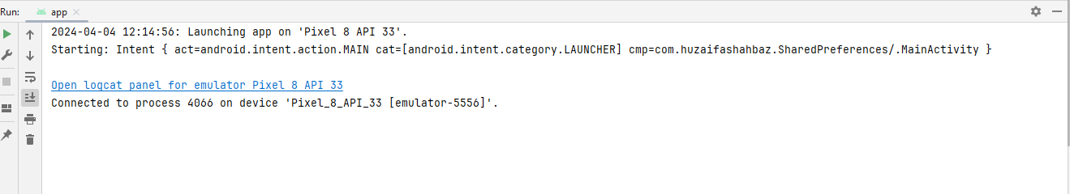
OUTPUT:
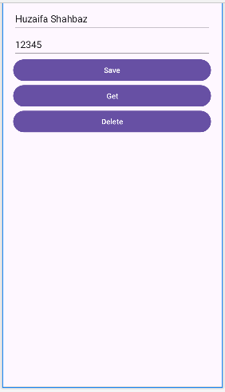
Home Task: Use Tasbeeh app and use shared preference to store history. Note: Shared Preference can only store strings.
JAVA CODE OF MAIN ACTIVITY:
package com.huzaifashahbaz.tasbeehappsharedpreferences;
import android.content.Intent;
import android.os.Bundle;
import android.view.View;
import android.widget.Button;
import android.widget.TextView;
import androidx.activity.EdgeToEdge;
import androidx.appcompat.app.AppCompatActivity;
import androidx.core.graphics.ColorUtils;
import androidx.core.graphics.Insets;
import androidx.core.view.ViewCompat;
import androidx.core.view.WindowInsetsCompat;
import java.util.ArrayList;
public class MainActivity extends AppCompatActivity {
private TextView countView;//initailize the textview
private Button countButton;//initialize the countbutton
private Button resetButton;//initialize the resetbutton
private Button viewHistoryButton;//initialize the viewhistoryButton
private int count=0;//initialize count
private ArrayList<CountEntry>countHistory;//initialize arraylist of counthistory
@Override
protected void onCreate(Bundle savedInstanceState) {
super.onCreate(savedInstanceState);
setContentView(R.layout.activity_main);//main activity java file
countHistory=CountSharedPreferences.getCountHistory(this);
//DEFINE UI COMPONENTS
countView=findViewById(R.id.count);//countview java file
countButton=findViewById(R.id.count_btn);//count_btn java file
resetButton=findViewById(R.id.reset_btn);//reset_btn java file
viewHistoryButton=findViewById(R.id.history_btn);//history_btn java file
//SET UP INITIAL COUNT
updateCountView();
//BUTTON LISTENERS
//COUNTBUTTON CLICKLISTENER FUNCTION
countButton.setOnClickListener(new View.OnClickListener() {
@Override
public void onClick(View view) {
count++;
updateCountView();
}
});
//RESETBUTTON CLICKLISTENER FUNCTION
resetButton.setOnClickListener(new View.OnClickListener() {
@Override
public void onClick(View view) {
countHistory.add(new CountEntry(count,System.currentTimeMillis()));
CountSharedPreferences.saveCountHistory(MainActivity.this,countHistory);
count=0;
updateCountView();
}
});
//HISTORYBUTTON ONCLICKLISTENERFUNCTION
viewHistoryButton.setOnClickListener(new View.OnClickListener() {
@Override
public void onClick(View view) {
Intent countIntent=new Intent(MainActivity.this,HistoryActivity.class);
startActivity(countIntent);
}
});
}
private void updateCountView()
{
countView.setText("Count:"+count);
}
}
JAVA CODE OF HISTORY ACTIVITY:
package com.huzaifashahbaz.tasbeehappsharedpreferences;
import android.content.DialogInterface;
import android.os.Bundle;
import android.view.View;
import android.widget.AdapterView;
import android.widget.ListView;
import androidx.activity.EdgeToEdge;
import androidx.appcompat.app.AlertDialog;
import androidx.appcompat.app.AppCompatActivity;
import androidx.core.graphics.Insets;
import androidx.core.view.ViewCompat;
import androidx.core.view.WindowInsetsCompat;
import java.text.SimpleDateFormat;
import java.util.ArrayList;
import java.util.Date;
import java.util.Locale;
public class HistoryActivity extends AppCompatActivity {
@Override
protected void onCreate(Bundle savedInstanceState) {
super.onCreate(savedInstanceState);
setContentView(R.layout.activity_history);//historyactivity javafile create
ListView historylist=findViewById(R.id.count_list);//count_list java file create
ArrayList <CountEntry> countHistory= CountSharedPreferences.getCountHistory(this);//arraylist
if (CountHistory !=null)
{
CountHistoryAdapter historyAdapter = new CountHistoryAdapter(this,R.layout.count_list_item,countHistory);//counthistoryadapter
historylist.setAdapter(historyAdapter);
historylist.setOnItemClickListener(new AdapterView.OnItemClickListener() {
@Override
public void onItemClick(AdapterView<?> adapterView, View view, int i, long l) {
showDateTimeDialog(countHistory.get(position));//datetimedialog
}
});
}
}
private void showDateTimeDialog(countEntry entry)
{
String formattedDate=formatDate(entry.getTimestamp());//string of formatted date
String dialogMessage="Count saved at:" + formattedDate;//string of dialogMessage
//build and show alertdialog
AlertDialog.Builder builder=new AlertDialog.Builder(this);
builder.setMessage(dialogMessage);
builder.setMessage(dialogMessage)
.setTitle("Count Information")//title of builder
.setPositiveButton("OK", new DialogInterface.OnClickListener() {//positive button of dialog interface
public void onClick(DialogInterface dialogInterface, int i) {
//user clicked on button
dialog.dismiss();
}
});
AlertDialog dialog= builder.create();//buildercreate of dialog
dialog.show();
}
private String formatDate(long timestamp)
{
SimpleDateFormat sdf=new SimpleDateFormat("yyyy-MM-dd HH:mm:ss", Locale.getDefault());
return sdf.format(new Date(timestamp));
}
}
CountsharedPreferneces:
package com.huzaifashahbaz.tasbeehappsharedpreferences;
import android.content.Context;
import android.content.SharedPreferences;
import java.util.ArrayList;
import java.util.HashSet;
import java.util.Set;
public class CountSharedPreferences {
private static final String PREF_NAME="CountPreferences";//string prefname
private static final String COUNT_HISTORY_KEY="countHistory";//string counthistory
public static void saveCountHistory(Context context, ArrayList<CountEntry> countHistory)
{
SharedPreferences.Editor editor=context.getSharedPreferences(PREF_NAME,context.MODE_PRIVATE).edit();//shared[reference editior
Set<String> countHistorySet=new HashSet<>();//counthistoryset
for (CountEntry entry:CountHistory)//for loop
{
countHistorySet.add(serializeCountEntry(entry));
}
editor.putString(COUNT_HISTORY_KEY,countHistorySet);
editor.apply();
}
public static ArrayList<CountEntry>getCountHistory(Context context)
{
SharedPreferences prefs= context.getSharedPreferences(PREF_NAME,Context.MODE_PRIVATE);
Set<String> countHistorySet=prefs.getStringSet(COUNT_HISTORY_KEY,null);
if (countHistorySet !=null)
{
ArrayList<CountEntry> countHistory=new ArrayList<>();
for (String serializiedEntry:countHistory)
{
countHistory.add(deserializedCountEntry(serializiedEntry));
}
return countHistory;
}
return new ArrayList<>();
}
private static String serializeCountEntry(CountEntry entry)
{
return entry.getCount()+ ","+entry.getTimestamp();
}
private static CountEntry deserializedCountEntry(String serializedEntry)
{
String[] parts =serializedEntry.split(",");
int count=Integer.parseInt(parts[0]);
long timestamp =Long.parseLong(parts[1]);
return new CountEntry(count,timestamp);
}
}
XML CODE OF MAIN ACTIVITY:
<?xml version="1.0" encoding="utf-8"?>
<LinearLayout xmlns:android="http://schemas.android.com/apk/res/android"
xmlns:app="http://schemas.android.com/apk/res-auto"
xmlns:tools="http://schemas.android.com/tools"
android:layout_width="match_parent"
android:layout_height="match_parent"
android:orientation="vertical"
android:padding="2mm"
tools:context=".MainActivity">
<LinearLayout
android:layout_width="wrap_content"
android:layout_height="wrap_content"
android:layout_marginHorizontal="14mm"
android:layout_marginTop="14mm"
android:orientation="vertical"
android:layout_gravity="center">
<TextView
android:id="@+id/app_title"
android:layout_width="match_parent"
android:layout_height="wrap_content"
android:gravity="center"
android:textSize="35sp"
android:textStyle="bold"
android:fontfamily="causal"
android:text="Tasbeeh App"/>
<TextView
android:id="@+id/count"
android:layout_width="match_parent"
android:layout_height="wrap_content"
android:layout_marginTop="15mm"
android:gravity="center"
android:textSize="25sp"
android:textStyle="bold"
android:fontFamily="monospace"
android:text="Count:0"/>
<LinearLayout
android:layout_width="wrap_content"
android:layout_height="wrap_content"
android:orientation="horizontal"
android:layout_gravity="center"
android:layout_marginTop="14mm">
<Button
android:id="@+id/count_btn"
android:layout_width="wrap_content"
android:layout_height="match_parent"
android:layout_marginHorizontal="1mm"
android:text="Alhamdulillah"
android:textSize="18sp"
android:fontFamily="casual"
android:textStyle="bold"/>
<Button
android:id="@+id/reset_btn"
android:layout_width="wrap_content"
android:layout_height="wrap_content"
android:layout_marginHorizontal="1mm"
android:text="Reset"
android:textSize="18sp"
android:fontFamily="casual"
android:textStyle="bold"/>
</LinearLayout>
<LinearLayout
android:layout_width="wrap_content"
android:layout_height="wrap_content"
android:orientation="horizontal"
android:layout_gravity="center"
android:layout_marginTop="14mm">
<Button
android:id="@+id/history_btn"
android:layout_width="wrap_content"
android:layout_height="wrap_content"
android:layout_marginHorizontal="18sp"
android:fontFamily="casual"
android:textStyle="bold"/>
</LinearLayout>
</LinearLayout>
</LinearLayout>

Results:

OUTPUT:
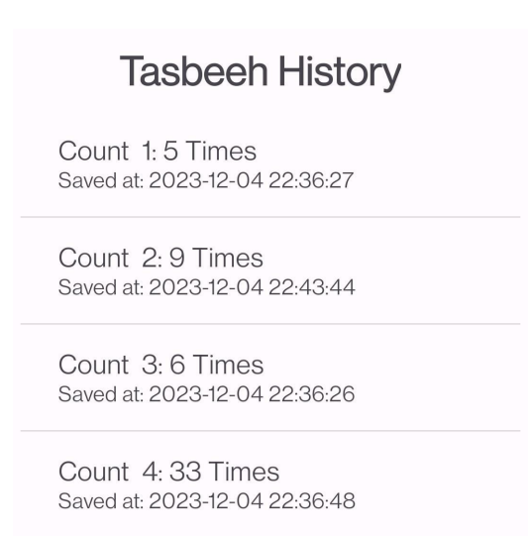
Conclusion: In conclusion, we had learned the shared preferences in mobile app.Also we know the working and function of tasbeehcounter and student form by using Java Code and XML linear layout.

